Nutrition

- What does the term ‘diet’ mean?

- What is the process your body uses to obtain energy from food called?

- Where in your body is the largest amount of energy used?

- What is the final product of all the energy changes that occur in your body and what is it used for?

- Use the information in the text to summarise the main types of chemicals in food matter in the table below.
Nutrient | Function in the Body | Foods High in Nutrient | Extra Information
Carbohydrates
Proteins
Fats and Oils
Vitamins and Minerals
- What effect do you think an unbalanced diet would have on your body?

- What two substances do both plants and animals need?

- Photosynthesis is the process plants use to make their own food
  - Write a word equation to describe photosynthesis.

  - What chemical causes the green colour in leaves and why is it important?

  - When does photosynthesis occur and why can it only occur then?

  - What does the plant do with the sugars it produces?

Practical Activity: Testing for nutrients.

There are some simple tests to determine the nutrients in food. You are going to carry out some of these tests, then test various food samples for nutrients

Part A: Testing for sugars
Equipment: 2 test tubes, labels, glucose solution, distilled water, Benedict’s solution, 250 mL beaker, Bunsen burner, tripod and gauze mat.

Procedure:
- Label two test tubes (A and B) and place them in a test tube rack.
- Add 10 mL of glucose solution to test tube A.
- Add 10 mL of distilled water to test tube B.
- To each test tube, add 5 drops of Benedict’s Solution
- Place the two test tubes in a 250 mL beaker containing 150 mL of water.
- Place the beaker on a wire mat over a tripod and heat with a Bunsen burner.
- Bring the water to the boil and heat the test tubes in the water for about 5 minutes.
- Record your results below.

Results:
 | Test Substance | Observations
Test tube A | Glucose
Test tube B | Water

Conclusion:

Part B: Testing for fats
Equipment: Brown paper, oil, water, butter

Procedure:
- Label three pieces of brown paper A, B and C.
- Add two drops of oil to the centre of A.
- Add two drops of water the centre of B.
- Rub some butter on C.
- Allow the paper to dry, and then hold it up to the light. Lipids leave a transparent mark.
- Record you observations below.

Results:
 | Test Substance | Observations | Are Lipids Present
Paper A | Oil
Paper B | Water
Paper C | Butter

Conclusion:

Part C: Testing for starch
Equipment: Two test tubes, labels, starch solution, distilled water, iodine solution.

Procedure:
- Label the test tubes A and B.
- In tube A, put 10 mL of starch solution.
- In tube B, put 10 mL of distilled water.
- Add 3 drops of iodine solution to each tube.
- Iodine turns black in the presence of starch.
- Record your results below.

Results:
 | Test Substance | Observations
Test Tube A | Starch
Test Tube B | Water

Conclusions:

Part D: Testing for Protein
Equipment: 2 test tubes, labels, protein solution, distilled water, 1M sodium carbonate solution, 0.1M copper sulphate solution

Procedure:
- Label the test tubes A and B.
- Add 10 mL of protein solution to test tube A.
- Add 10 mL of distilled water to test tube B.
- To each tube, add one eye-dropper full of sodium carbonate solution.
- Add one or two drops of copper sulphate solution.
- The solution will turn violet in the presence of protein or will remain pale blue in the absence of protein.
- Record your observations below.

Results:
 | Test Substance | Observations
Test Tube A | Protein
Test Tube B | Water

Conclusion:

Part E: Testing Foods
You are now going to use the tests you have performed to test various food samples for different nutrients. Each group will be required to test at least three or four samples, however if time permits your group may test more.

To test your sample of food you will need to first crush it with a mortar and pestle. You will then need to add a small amount of distilled water to your food sample to create a sludge. This will form your test sample.

Use the steps outlined in parts A to D to identify the presence of the different nutrients in your food sample.

Record your observations and the results of your tests in the table on the next page.

For each new food sample, you will need to wash all your equipment thoroughly to avoid cross contamination between food samples.

Questions:

- In parts A-D, what was the purpose of performing each test on distilled water?

- Which food had the most different types of nutrients present? Which nutrients did it have?

- Which food had the least different types of nutrients present? Which nutrients did it have?

- Which nutrient was in the most foods? Which foods was it in?

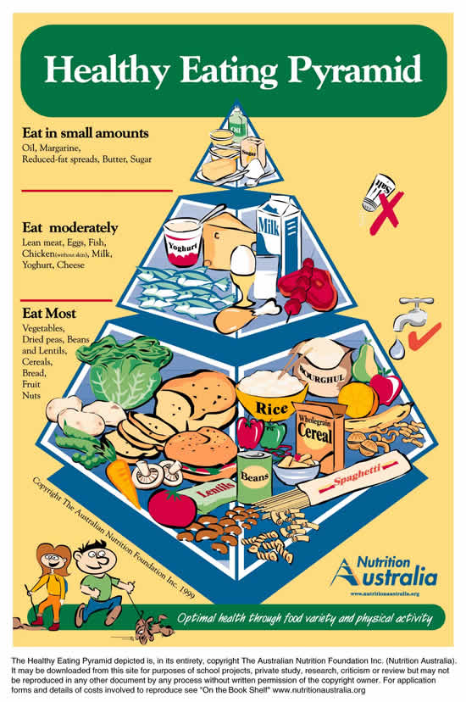
- The healthy eating pyramid is used as a guide to show what a balanced diet should look like.
  - What foods does the pyramid suggest should be eaten most? What types of nutrients do these foods contain?

  - What types of foods should be eaten in moderation? What types of nutrients do these foods contain?

  - What foods should be eaten only in small amounts? What types of nutrients do these foods contain?

